Figures & Tables: The effect of a commercial *Ascophyllum nodosum* extracts on tomato and pepper plant productivity and their associated fungal and bacterial communities.

December 06, 2018

**Sébastien Renaut1,2 ,Jacynthe Masse1,2 , Jeffrey P. Norrie3 , Bachar Blal3 Mohamed Hijri1,2**

*1Département de Sciences Biologiques, Institut de Recherche en Biologie Végétale, Université de Montréal, 4101* *Sherbrooke Est, Montreal, H1X 2B2, Quebec, Canada.*  *2Quebec Centre for Biodiversity Science, Montreal, Quebec,*  *Canada 3Acadian Seaplant Ltd, 30 Brown Avenue, Darthmouth, Nova Scotia, Canada, B3B 1X8*

Table 1: Soil characteristics (in ppm unless specified otherwise)

|  |  |
| --- | --- |
| Soil Characteristics | Average value |
| pH | 6.01 |
| Conductivity (mmhos/cm) | 0.68 |
| Nitrate (N) | 62.40 |
| Ammonium | 0.09 |
| Phosphorus | 0.41 |
| Potassium | 29.30 |
| Calcium | 64.40 |
| Magnesium | 13.80 |
| Chloride | 28.50 |
| Sulfate | 19.30 |
| Sodium | 17.80 |
| Zinc | 0.12 |
| Manganese | 0.06 |
| Cooper | 0.81 |
| Iron | 0.90 |
| Aluminium | 1.66 |

Table 2: Summary of sequencing and bioinformatics identification of ASVs

|  |  |  |  |  |
| --- | --- | --- | --- | --- |
|  | fungi-soil | fungi-root | bacteria-soil | bacteria-root |
| No sequences (sum) | 976,000 | 309,000 | 920,000 | 535,000 |
| No sequences (mean) | 50,847 | 32,208 | 47,907 | 56,365 |
| No seq. filtered (mean) | 32,626 | 12,714 | 29,662 | 37,642 |
| No seq. filt. merged (mean) | 29,300 | 12,094 | 14,060 | 30,706 |
| No seq. filt. merg. no chimeras (mean) | 25,476 | 9,849 | 13,521 | 30,408 |
| No samples | 192 | 96 | 192 | 96 |
| No samples trimmed | 189 | 81 | 192 | 95 |
| No ASVs (sum) | 6,112 | 845 | 9,352 | 2,023 |
| No ASVs trimmed (sum) | 413 | 106 | 811 | 325 |
| ASV per sample (mean) | 176 | 37 | 269 | 92 |

Table 3: summary of PERMANOVAs

|  |  |  |  |  |
| --- | --- | --- | --- | --- |
|  | fungi-soil | fungi-root | bacteria-soil | bacteria-root |
| fertilization | 0.02*** | 0.08*** | 0.04*** | 0.07*** |
| planted | 0.21*** | NA | 0.13*** | NA |
| species | 0.02*** | 0.26*** | 0.02*** | 0.52*** |
| fertilization:planted | 0.01** | NA | 0.02*** | NA |
| fertilization:species | 0.01* | 0.04* | 0.03*** | 0.05*** |
| planted:species | 0.01 | NA | 0.01** | NA |
| fertilization:planted:species | 0.01 | NA | 0.01* | NA |

$r^{2}$ (percentage of variance explained by the term in the model); *\*p-value<0.05, **<0.005, ***<0.0005*

Table S1: Experimental design

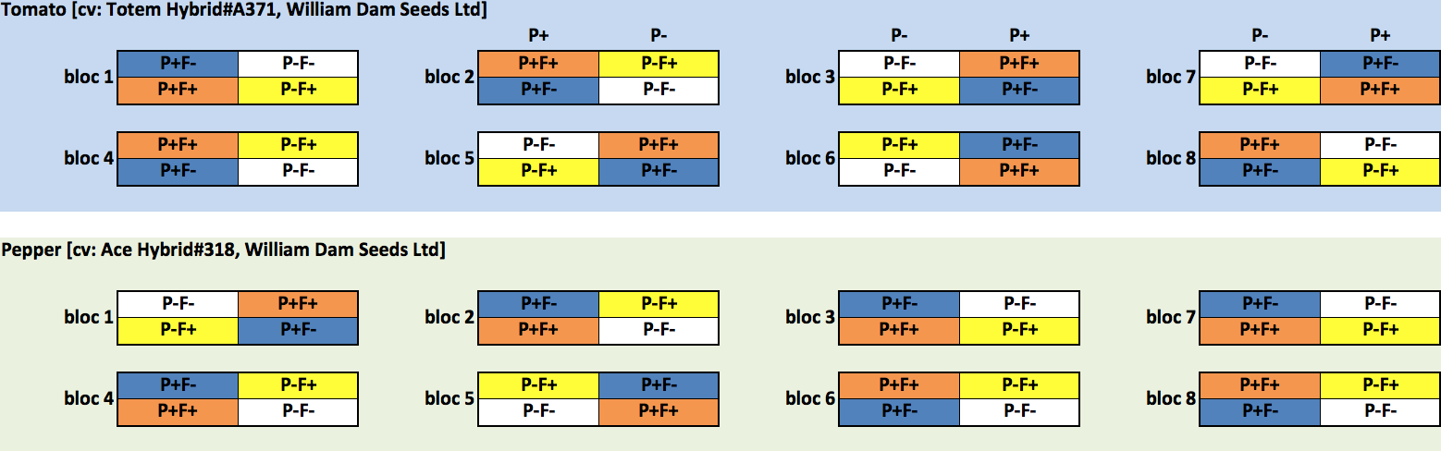

TableS2: Stella Maris® characteristics

|  |  |
| --- | --- |
| Stella Maris® characteristics | Average value |
| Appearance | Viscous Brownish-Black Liquid |
| Odor | Marine Odor |
| Solubility in water (%) | 100 |
| pH | 7.4 - 8.2 |
| Carbohydrates | Alginic acid, Mannitol, Fucoidans |
| Organic matter content (%) | 13.0 - 16.0 |
| Total Nitrogen (N) (%) | 0.1 - 0.6 |
| Available phosphate (P2O5) (%) | < 0.2 |
| Soluble potash (K2O) (%) | 5.0 - 7.0 |
| Sulphur (S) (%) | 0.3 - 0.6 |
| Magnesium (Mg) (%) | 0.05 - 0.15 |
| Calcium (Ca) (%) | 0.05 - 0.15 |
| Sodium (Na) (%) | 0.7 - 1.2 |
| Iron (Fe) (ppm) | 30 - 90 |
| Cooper (Cu) (ppm) | < 4 |
| Manganese (Mn) (ppm) | 3 - 11 |
| Boron (B) (ppm) | 20 - 40 |

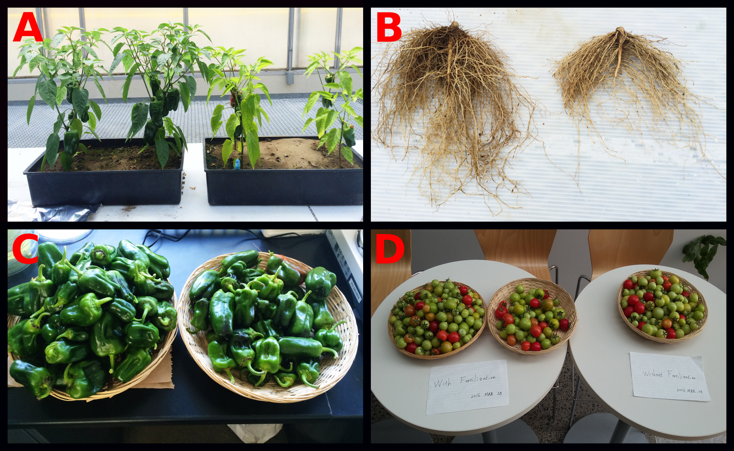  
**Figure 1: Plant productivity. Photos were taken at the end of the experimental treatment. In each photo, fertilized plants are on the left. A: pepper shoots, B: pepper roots, C: pepper fruits and D: tomato fruits.**  
 

   
Figure 2  
**Figure 2: Measures of plant productivity. *a* and *b* subscripts above boxplots denote significant differences according to the fertilization treatment. Fold changes between the mean of the control and fertilized plants were also noted for significant changes (for pepper and tomato separately).**  
   
   
   
Figure 3a  
**Figure 3a: Barplots of the relative abundance of fungal ASVs for fungi**  
   

Figure 3b  
**Figure 3b: Barplots of the relative abundance of bacterial ASVs for bacteria**

   
Figure 4  
**Figure 4: Boxplot of $a$-diversity according to the treatment, species and planting effect for fungal-root, fungal-soil, bacteria-soil and bacteria-root. *a* and *b* subscripts above boxplots denote significant differences.**  
 

   
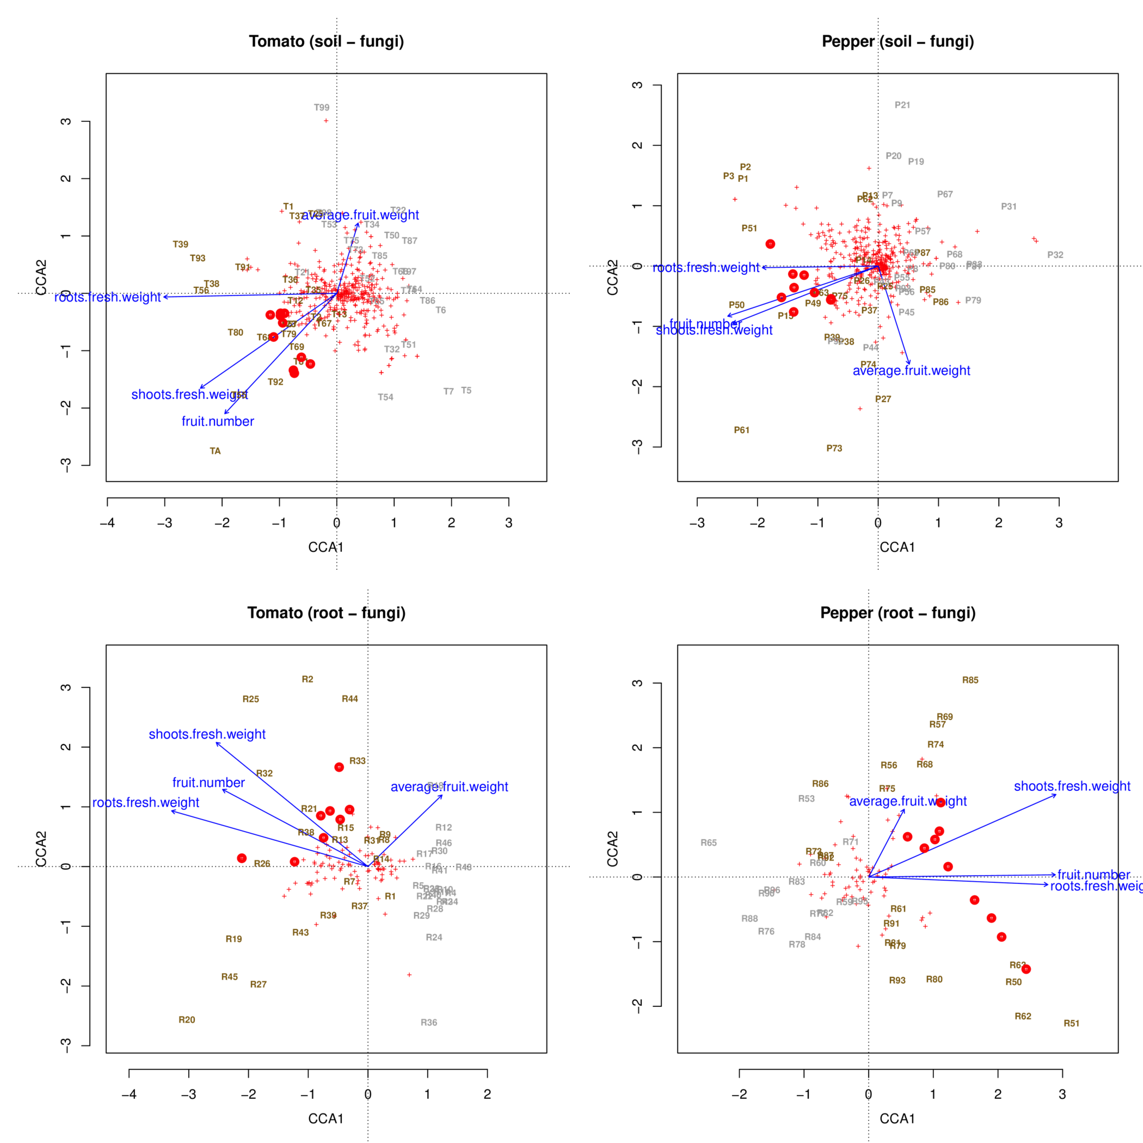  
**Figure 5a: Canonical correspondence analyses for soil-fungi and root-fungi. Samples were labeled and colored in gray (unfertilized) or dark yellow (fertilized). Red crosses represent individual ASVs, while red points represent the ten ASVs most closely associated with the three productivity measures of root fresh weight, shoots fresh weight and fruit number. Blue arrows are the four productivity measures used as constraints in the ordinations.**  

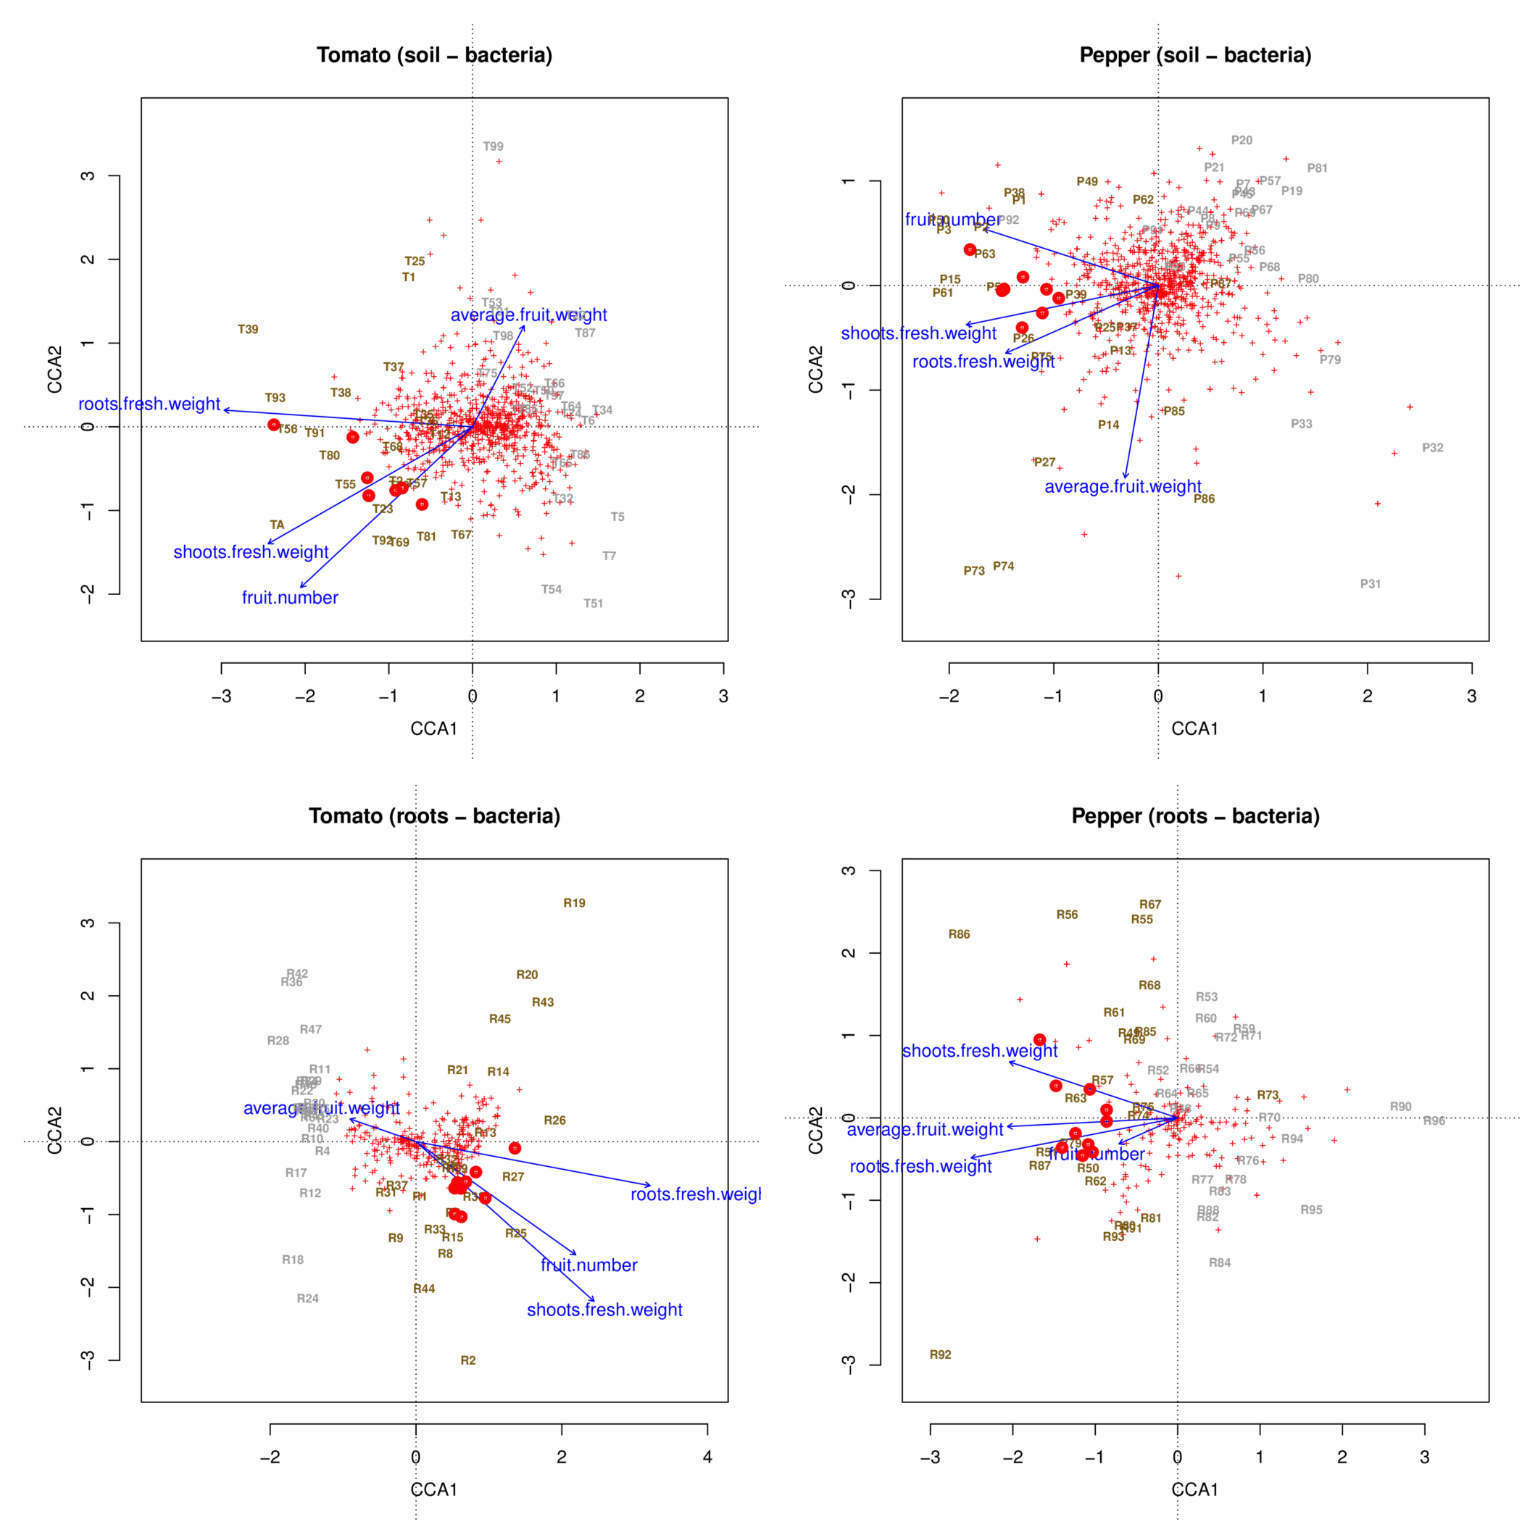  
**Figure 5b: Canonical correspondence analyses for soil-bacteria and root-bacteria. Samples were labeled and colored in gray (unfertilized) or dark yellow (fertilized). Red crosses represent individual ASVs, while red points represent the ten ASVs most closely associated with the three productivity measures of root fresh weight, shoots fresh weight and fruit number. Blue arrows are the four productivity measures used as constraints in the ordinations.**

Figure 6**Figure 6: Neighbor-Joining trees of candidates ASVs (fungi) positively associated with productivity measures. The most accurate taxonomy assigned according to the RDP bayesian classifier (form Phylum to species) was added as tip labels.**  

Figure S1  
**Figure S1: Neighbor-Joining trees of candidates ASVs (bacteria) positively associated with productivity measures. The most accurate taxonomy assigned according to the RDP bayesian classifier (form Phylum to species) was added as tip labels.**